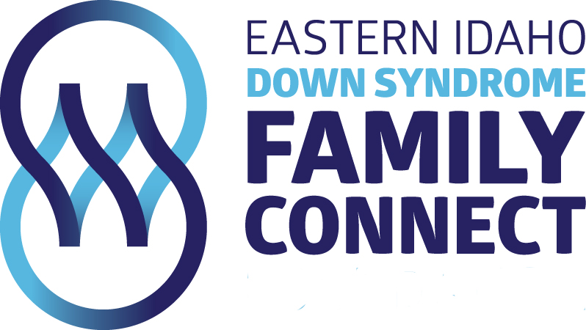
July 11, 2017

Attending:
Rochelle Larsen
Mary Murray
Karen Hunt
Jamie Jackson
Amy Jenson

Minutes from last meeting: Karen
- Liz Batt is on board to do an oraganized playgroup…offered $50 to provide snacks
- Mission statement thoughts?
- Does Amy have any updates on the blog?

Rochelle:
- Rexburg Rapids—August 5, 2017 BBQ 5-6, Swimming 6-9
  - Grilling—Mary and 2 friends
  - Set up—Karen and Rochelle
  - Clean up
- Race Update
- Hanging posters
- Basket/gift idea for Angie—Rochelle purchased plaque for Angie, will spend $50-70 on merchandise from Bill’s Bike and Run and then a $200 gift card to Bill’s Bike and Run
- Mary, Jamie and Kesley Salsbury to meet with Angie in September and hopefully get race info…Jamie will set up meeting.
- Committees
- Race
- Older kids activities
- Younger kids PALS—Liz Batt will take charge
- Holiday parties—Karen will ask Heidi to help out and have others help out in Sugar City area, Rochelle will talk to Stephanie Hansen to help with Christmas party
- DSAIA
- Global Down Syndrome—Let group members know of an upcoming webinar for free on Sept. 5 @12:00. Hopefully website will be up and info will be on that.

Mary:
- Empowerment Retreat Review—went great! May 7-10, 2018
- Dad’s day review and budget—went great, $500 was spent instead of $1000 which we thought it would cost. Will do retreat again.

- Website update
- Brochure update
- Katie Well’s pictures

Motions Passed—
No scholarship applications will be acted upon unless foundation has access of no less than $20,000 in free cash.

Voted to have Kelsey Salsbury on the board once we receive Angie Mago’s resignation. Kelsey will be an independent member.

New Events—
Informational meeting on rights our children have concerning their IEP’s. We want IPOL to be involved, Mary will contact them. Title will be:
IEP and Parent’s Rights in the School District
Pass out scholarship applications and Karen will be in charge of food.

